**Exercise 1: Online Bookstore - Setting Up RESTful Services**

Business Scenario:

You are tasked with developing a RESTful service for an online bookstore. The service will manage books, authors, and customers.

**Instructions:**

1. **Setup Spring Boot Project:**
   * **Project Name:** BookstoreAPI
   * **Dependencies Added:**
     + **Spring Web:** To create RESTful web services.
     + **Spring Boot DevTools:** To enhance development experience with features like automatic restarts.
     + **Lombok:** To reduce boilerplate code through annotations

**Project Structure:**

* **src/main/java:** Contains the application’s main code, including the BookstoreapiApplication.java class.
* **src/main/resources/application.properties:** Configuration file for setting up application-specific properties.
* **pom.xml :** Configuration file for managing dependencies and project settings.

1. **What's New in Spring Boot 3:** Exploring the new features introduced in Spring Boot which include:

* **Java 17 Support:** Full compatibility with the latest features and enhancements of Java 17.
* **Native Executables:** Ability to compile Spring Boot applications into native executables using GraalVM, leading to improved startup time and reduced memory usage.
* **Enhanced Observability:** Built-in support for metrics and tracing, making it easier to monitor applications.
* **Improved Dependency Management:** Updated dependencies and improved performance optimizations.

**Code Setup:**

**Main Application Class:**

* The BookstoreapiApplication.java file contains the entry point for the Spring Boot application.
* The class is annotated with @SpringBootApplication, which enables essential Spring Boot features like auto-configuration and component scanning.

**Configuration : application.properties**

**FLOWCHART :**

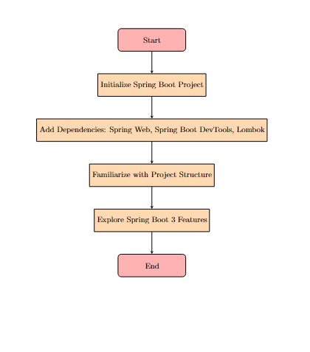

**Explanation:**

1. **Start**: The process begins with the initiation of the task to set up RESTful services for the online bookstore.
2. **Initialize Spring Boot Project**: You start by creating a new Spring Boot project named BookstoreAPI. This includes setting up the basic structure and initializing the project with the necessary files.
3. **Add Dependencies**: You then add essential dependencies such as Spring Web (to build web applications, including RESTful services), Spring Boot DevTools (to improve development experience), and Lombok (to reduce boilerplate code).
4. **Familiarize with Project Structure**: Once the project is set up, you need to explore the generated project structure to understand the organization of files and directories.
5. **Explore Spring Boot 3 Features**: This step involves investigating and documenting the new features introduced in Spring Boot 3, which may provide improvements and enhancements to your application.
6. **End**: The process concludes with the completion of the initial setup and exploration.

**CLASS DIAGRAM :**

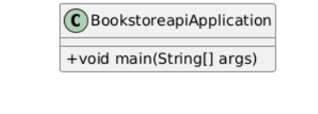

**Explanation:**

* **BookstoreapiApplication**: This is the main class of the BookstoreAPI project. It contains the main method, which serves as the entry point for the Spring Boot application.
  + +void main(String[] args): The main method is public (+), returns void, and accepts a String[] as an argument, which is typical for a Java application's entry point.